Project Title: Increasing the number of people in our Leamington Spa Primary Care Network population taking up and maintaining walking and running to improve their mental and physical health.
Dr Jo Fleming (Health and Wellbeing Coach) and Dr Hussain Al-zubaidi (Lifestyle GP)
A brief description of the proposal:
Leamington Primary Care Network (PCN) is made up of the eight NHS GP surgeries located in Leamington Spa, and serves a population of 85,000 patients. These are spread across North Leamington (Clarendon Lodge, Sherbourne, Waterside and Cubbington) and South Leamington (Croft, Warwick Gates, Spa and Whitnash). The project detailed in this application has an overall aim of increasing the number of patients in our Leamington Spa Primary Care Network population who take up and maintain walking and running to improve their physical and mental health, through running and walking peer support groups. In turn, we aim to provide patients who had not previously considered running as a form of mental and physical health support with the platform to try this in a safe, friendly, and supportive environment.
Aim: To increase the number of people in our Leamington Spa Primary Care Network population taking up and maintaining walking and running to improve their mental and physical health, through guided running and walking peer support groups led by healthcare professionals who are qualified run leaders.
Outcomes:
- To increase and maintain the regular number of people attending our established Leamington PCN ‘Run Talk Run’ and ‘Walk Talk Walk’ groups https://www.clmp.org.uk/pages/CLMP-Fitness-Club.
- To increase the numbers of patients joining our intermediate run/walk group and eventually onto our running group, through initiation of three NHS App Couch to 5km specific groups per year.
- To improve people’s overall experiences of taking part in ‘Run Talk Run’ and ‘Walk Talk Walk’ (hence increasing retention), by putting on special ‘themed’ events over the year.
- To improve our population’s knowledge, and that of their primary care health providers, of the groups through social media promotion and advertising.
- To demonstrate the importance running and walking has for our health and targeting our patients who will most benefit from it.

NHS App Couch to 5km (parkrun) group
In a new addition to what we currently offer, in 2024, we will run three NHS App Couch to 5km (parkrun) blocks per year, each one lasting 9 weeks in total. At each of the three set time periods, we will recruit a group of 12 patients (who cannot currently run 5km) and take them on the 9 week NHS App Couch to 5km journey. The plan can be found here: https://www.nhs.uk/live-well/exercise/running-and-aerobic-exercises/get-running-with-couch-to-5k/ . The start date will be decided and a coinciding Leamington parkrun date for all participants and health professionals to take part in. We will recruit both patients and staff to our group. Patients will be recruited using batch text messaging to targeted groups, with a link to a booking form on the Clarendon Lodge website. This has proved very successful in recruiting to our Lifestyle Clinics, and we are confident in this method of recruitment. Staff members will be notified of the group via usual practice staff notification channels and also encouraged to sign up.
In Week 1 of each block, we will invite patients to an initial 45 mins ‘Welcome Event’ held at Clarendon Lodge Medical Practice, where we will introduce the NHS Couch to 5km app, explain how the following 9 weeks will work, and take patients through an ‘Introduction to Running’ session where we will explore people’s reasons for signing up, as well as explore and alleviate any concerns or barriers. We will then take them on their first walk/run session. The remaining two sessions of that week will be completed by patients on their own, although they will be encouraged to meet up with others in the group where possible to do them together (we will set up a WhatsApp group for each cohort to facilitate this). Over the remaining 8 weeks, the first session of each week will be done altogether at our Monday night Run Talk Run group.
The group will ‘graduate’ after 9 weeks at Leamington parkrun, after which, patients can continue to run each Monday with our regular Run Talk Run group. All eight practices in Leamington PCN are parkrun practices and have an excellent relationship with the Leamington parkrun core team. Leamington parkrun are welcoming of this initiative and will be happy to encourage our ‘Couch to 5km’ graduates on the day.

Special ‘Themed’ Events
Since 2022/2023 we have put on the following special ‘themed’ events for our current running and walking groups, and plan to continue them in 2024, as putting on such events has boosted numbers and created further participation throughout the year. It has also encouraged GP practice staff members to attend. Here is an example of what these events will entail, based on 2023. We will continue to improvise and adapt in 2024, to encourage attendance.
Event | Description
Easter | Clues are set for locations around Leamington Spa and participants walk/run to each before returning to the medical practice for Easter based treats. | 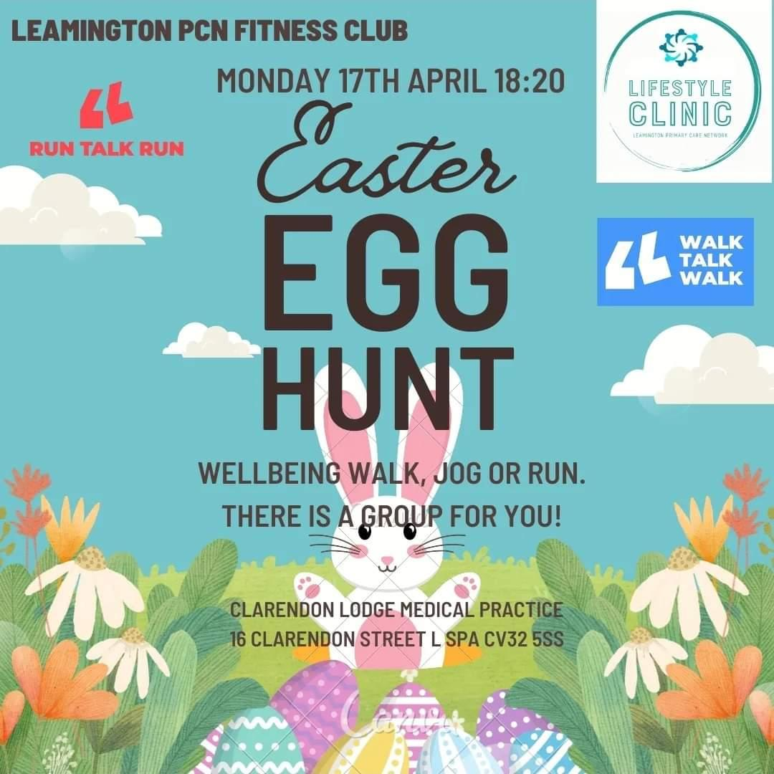
Mental Health Awareness | A brief talk by our Health and Wellbeing Coach on the year’s theme, including a table of resources available to download or take away (2023 was an introduction to ‘anxiety’ followed by our usual walk and run). | 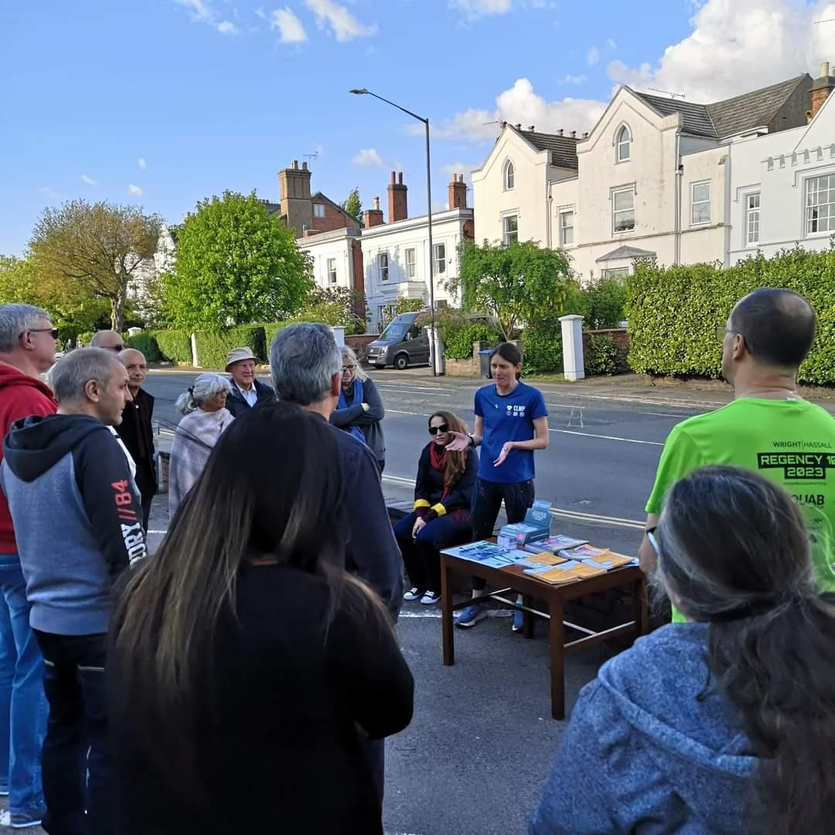
Summer Picnic | Our usual walk and run, followed by a picnic at the top of Beacon Hill in Newbold Comyn park, Leamington. | 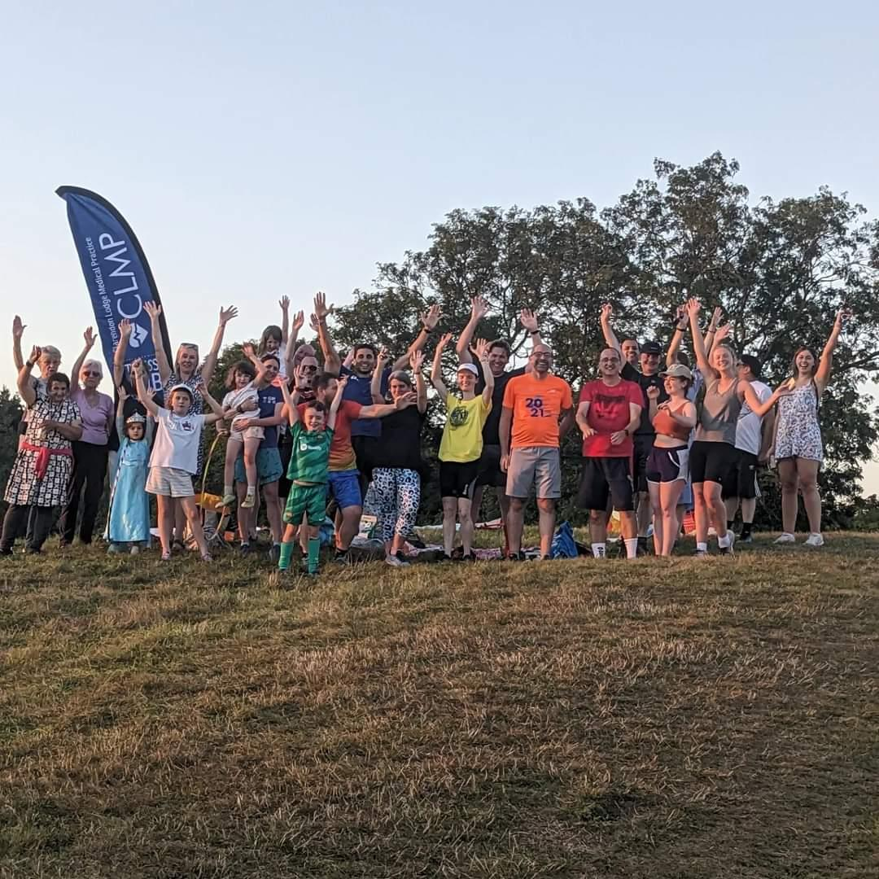
Halloween | Clues are set for locations around Leamington Spa and participants walk/run to each before returning to the medical practice for healthy pumpkin treats, produced by our dieticians to encourage pumpkin use and reduce food waste. | 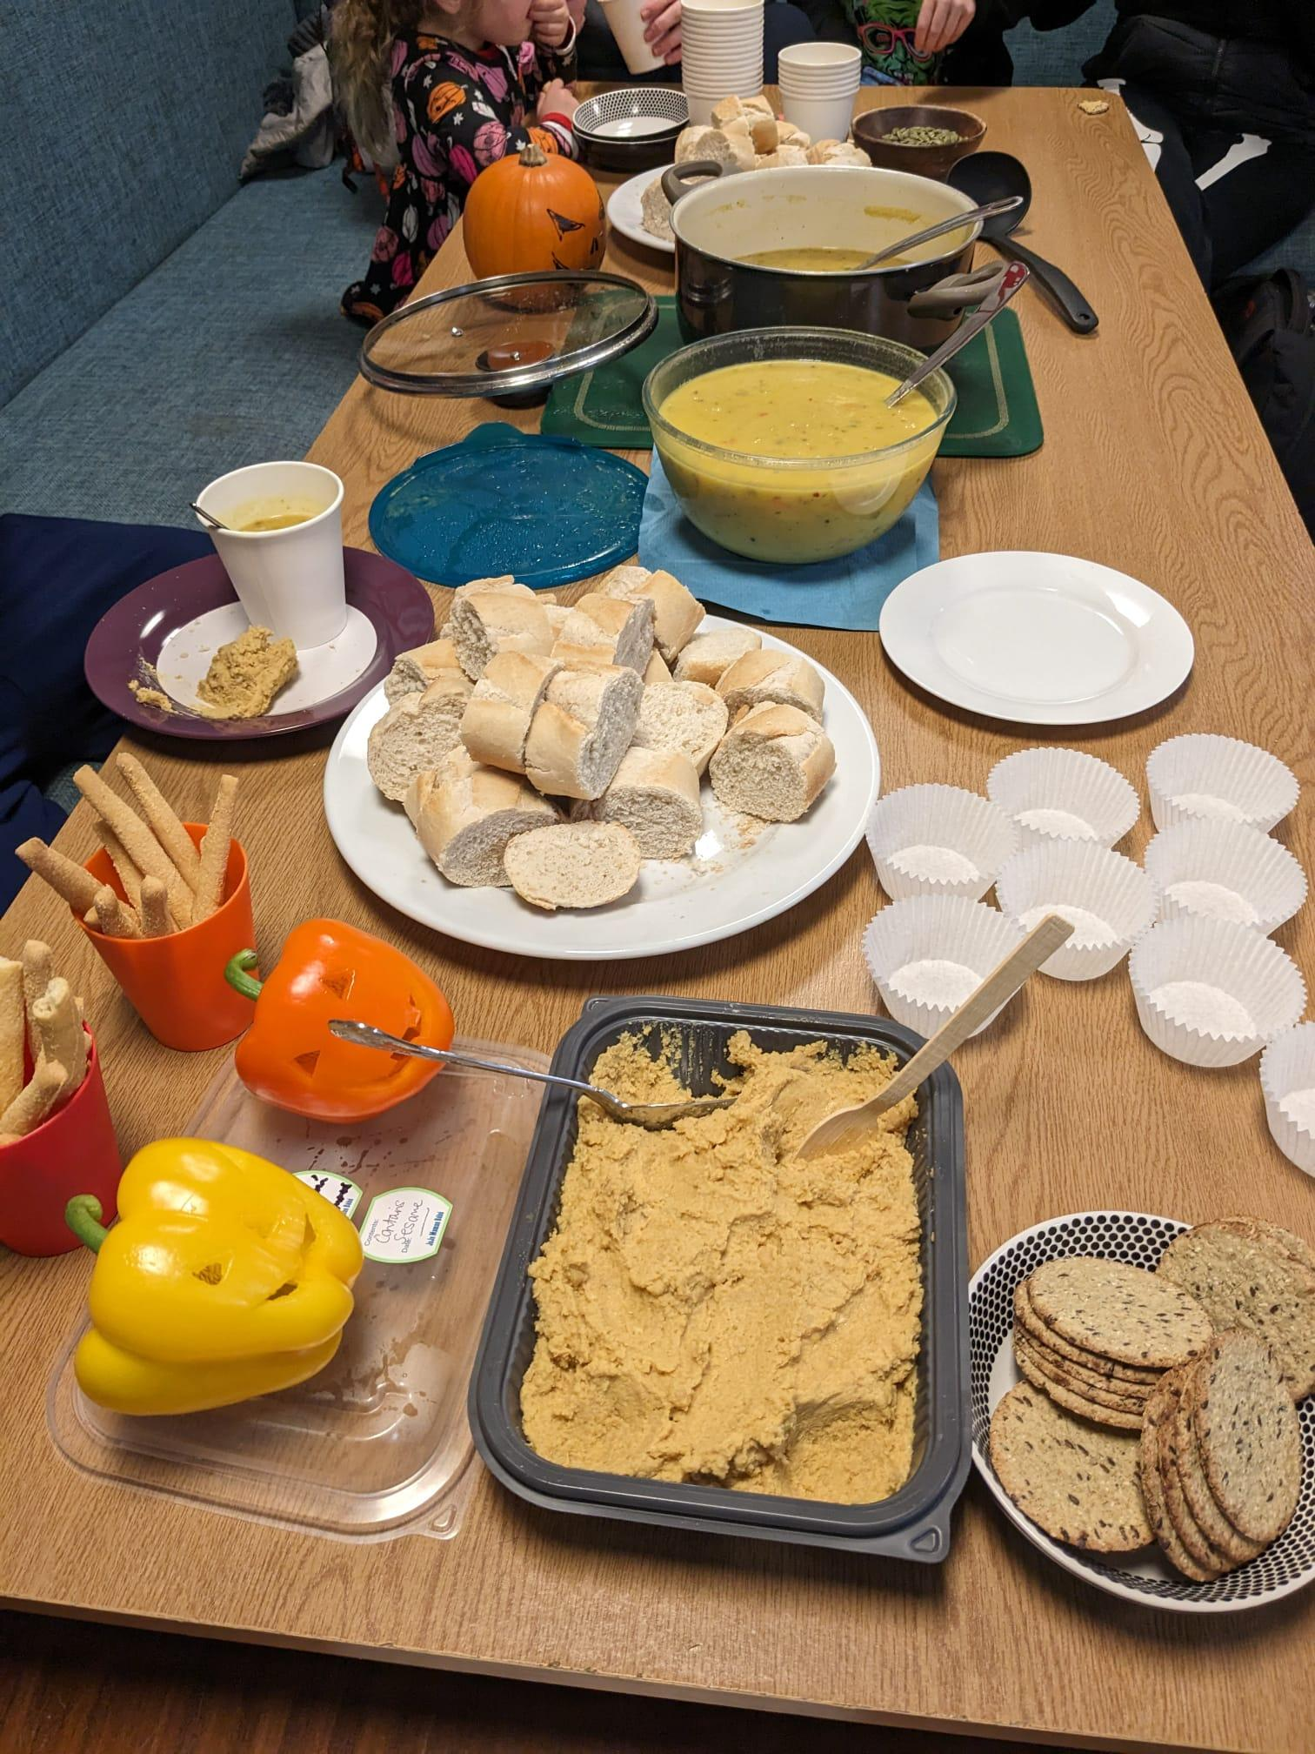
Christmas | Our usual walk and run (taking in as many festive lights as possible), followed by mulled wine and Christmas treats at Clarendon Lodge Medical Practice. | 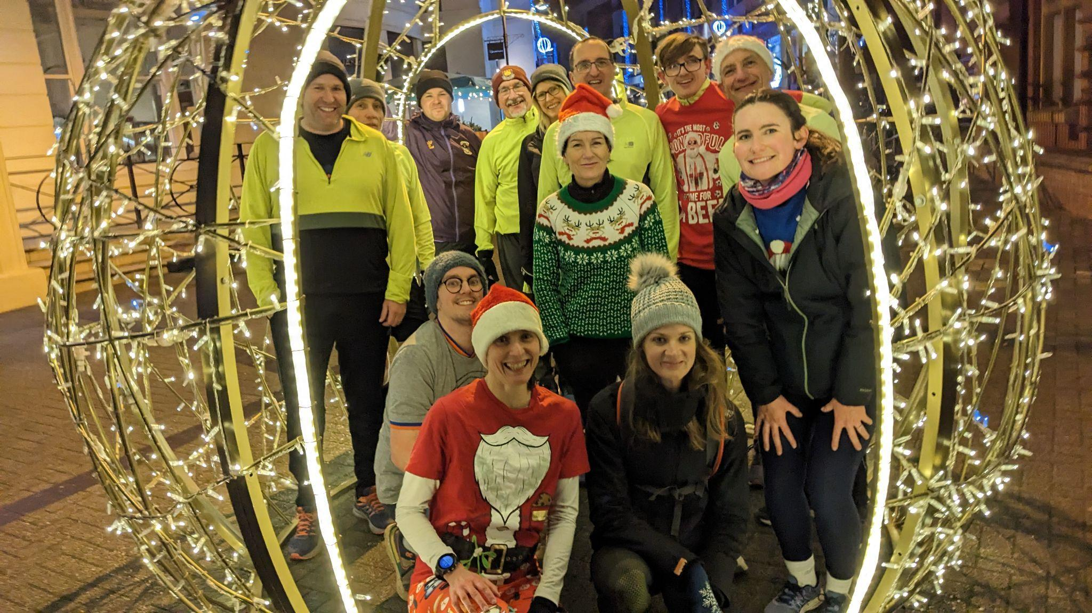

The amount of funding requested is: £743

An overview of how funds would be spent:
Between 2020 and 2022, our North Leamington Run Talk Run and Walk Talk Walk groups were funded with the help of a small grant from ThinkActive (£900). In 2023 we received funding from Leamington Town Council Grant (£1000) to set up a new Walk Talk Walk group in South Leamington, as well as to continue to promote all our groups, and put on special events throughout the year to encourage more people to take part and to keep regulars motivated.
We run the group under the Run Talk Run / Walk Talk Walk banner, which provides us with all the legal and insurance policies we need. Further details can be found here: https://www.runtalkrun.com/. There is no additional cost in being linked with this organisation. They are a non-profit organisation and therefore do not provide us with any additional funding. The groups are currently run by primary health care staff, including a GP at Clarendon Lodge, as well as a Social Prescriber Link Worker and a Health and Wellbeing Coach, both of whom are employed via the NHS Additional Roles scheme. No additional costs are required to cover their time in delivery of the group as the NHS primary care network in Leamington are committed to delivering these sessions. However, we will require additional funding this year to accommodate an additional run leader from a local running club, to lead one of the groups (either run, couch to 5km, power walk or walk), as we currently do not have enough paid staff to cover all 4 groups. In time, this role will be covered by an additional staff member if it proves successful, and so this cost will not be required for the sustainability of the group.
Other upfront costs of the groups are now established, and the funding we are applying for in this instance is to maintain the effective running of these groups and enhance their experience, including putting on regular special events throughout the year with food and drinks to entice people to come along and create community spirit.

Table 1: Breakdown of Costs Required
Item needed Number Cost per item Total | Reason needed | Number | Cost per item | Total cost
Promotion
Social media | Promotion of groups and special themed events | 1 boost per month | £6 | £72
Batch texting people who are inactive and/or poor mental health inviting them to the walk/run / do the NHS Couch to 5km App runs as a group. | This method is effective in getting patients to attend our lifestyle clinics, and targeted correctly will reach a lot of patients. | 800 (£0.02) per text | £16 | £16
Couch to 5km (parkrun group)
NHS Couch to 5km (parkrun) start up event in Week 1, plus lead/debrief after each session | To introduce patients to the Couch to 5km app, talk them through running for health at Week 1, plus a weekly debrief after each weekly run.  Use of a Leader in Running Fitness from a local running club. | 27 sessions/year  3 x 9 week blocks/year | £15/session | £405
Additional Special Events
Easter Event  March/April | Special event with food and drinks to entice people to come along and create community spirit | 2 |  | £50
Mental Health Awareness  May | Special event with food and drinks. Bring about awareness of physical activity and community to help with mental health. Link up with Mental Health UK for promotional ideas | 2 |  | £50
Summer Picnic Event  July | Special event with food and drinks (including foraging activity during walk/run) | 2 |  | £50
Halloween Event  October | Special event with food and drinks to entice people to come along and create community spirit plus how to create healthy recipes with pumpkins and avoid waste | 2 |  | £50
Christmas Event  December | Special event with food and drinks to entice people to come along and create community spirit | 2 |  | £50
TOTAL |  |  |  | £743

